AI Homework 4
1)
a) - A state is a 3x3 board where each cell holds X,0 or empty. The player to move can be derived from the board...if X count = O count, it is X’s turn, otherwise it’s O’s.
- The initial state is S₀, the empty board
- Players exist in {X, O), where X is the max and O s is the minimum.
- Legal Actions are ACTIONS(s), the set of empty cells. An action means the player moves to that cell. At most, there are 9 available actions.
- The transition model returns a brand new board identical to . The turn passes to another player.
- Terminal test is true if either some line is ifkleld with the same mark, or no empty cell remains empty
- The utility function +1 if X has three in a row
-1 if O has O has 3 in a row
b) - A game-tree node contains a state inside a structure containing a state, the parent, action, depth, children, and value
- A game-tree node relates to a game state because it contains values regarding the game such as state, depth, value...
c) - Tic-tac-toe is deterministic as the result of a move is entirely determined by the state and action
- It is fully observable as every piece and space on the board is visible to both players at all times, there is no information missing
- It is sequential because players take alternating turns playing and player’s moves are known
- It is zero-sum because utilities always sum to zero, one player’s gain is exactly the other’s loss, vice versa...
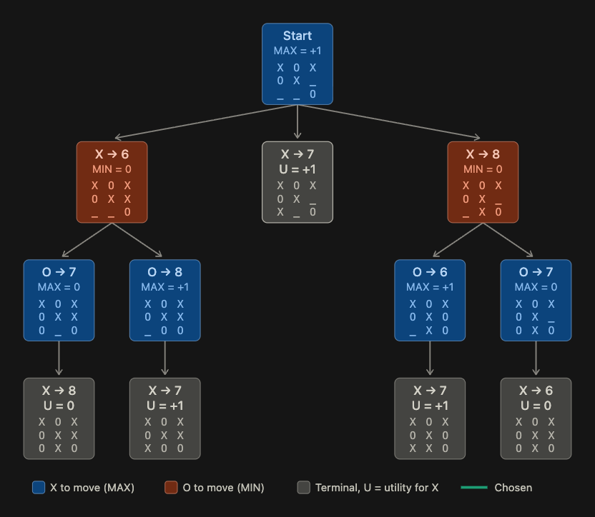

2c) The move X to position 7 has a utility of +1 because the user wins the game by placing an X in that location, so the advantage/utility is +1 for that case.

3a)
Step | Node | α, β on entry | What happens
1 | Root (MAX) | −∞, +∞ | Visit X→6 first.
2 | X→6 (MIN) | −∞, +∞ | Visit O→7 first.
3 | O→7 (MAX) | −∞, +∞ | Its only child, X→8, is a leaf with U = 0. v = 0 and α becomes 0. Returns 0.
4 | X→6 (MIN) |  | v = 0, so β becomes 0. Now α = −∞, β = 0.
5 | O→8 (MAX) | −∞, 0 | Its only child, X→7, is a leaf with U = +1. v = +1 and α becomes 1. Now α ≥ β (1 ≥ 0), but no children remain, so nothing is skipped. Returns +1.
6 | X→6 (MIN) |  | v = min(0, +1) = 0. Returns 0.
7 | Root (MAX) |  | v = 0, so α becomes 0.
8 | X→7 (leaf) |  | U = +1. Root v = 1, so α becomes 1.
9 | X→8 (MIN) | 1, +∞ | Visit O→6 first.
10 | O→6 (MAX) | 1, +∞ | Its child X→7 is a leaf with U = +1. v = +1, α stays 1. Returns +1.
11 | X→8 (MIN) |  | v = 1, so β becomes 1. Now α = 1 ≥ β = 1, so it stops here. The O→7 child, and its leaf X→6, are skipped. Returns 1.
12 | Root (MAX) |  | v = max(1, 1) = 1. Returns +1.

3b) The 0 -> 7 branch under X -> 8 is pruned, under the condition that when X -> 8 is reached, the root already has a = 1 from the X -> 7 win. After its first child O→6 returns +1, its value is at most 1 (β = 1). MAX already has a guaranteed 1 elsewhere, and X→8 cannot give X more than that. Its other child can only lower X→8's value or leave it at 1, and neither changes the root's choice. The condition is a tie (1 ≥ 1), and a tie is enough because MAX gains nothing by switching to an equal value

3c) The alpha-beta algorithm returns the same move and root value as minimax, so whatever value returned from the completed tree is also the move returned by alpha-beta.

3d) Changing the order in which children are visited would not change the final minimax value because alpha-beta is an optimization of minimax, not an approximation. The number of nodes pruned would absolutely be affected. If a more optimal node was scanned will determine the pruning of other branches.

4d) I tested the program using rules and terminal handling, specific positions, exhaustive checks, and self-play.
At X’s expected move to square 2, it would have been an immediate win because playing 2 would complete the top row. However, noticed this and blocked X’s threat. At square 6, X would have completed the diagonal 2-4-6. In square 5, O would have won over the possibility of blocking X.

5) If the logic were applied to a much larger game like chess, there would be a realm of different challenges. Firstly, not all the pieces have the same functionality, so it would have to understand movements, protecting the king, etc.. Second, chess is a much larger board space than tic-tac-toe so the time and space complexity would increase over the tic-tac-toe game. There would need to be a stronger evaluation function in place to understand the type of piece at what location and the possibilities of expanding that that specific piece may have compared to another different piece on the board. Also, logic is much harder to plan out.. in tic-tac-toe it is very easy for the agent to see and predict possibilities and changes relative to the end of the game. Since there is more pieces, more spaces, and different, more complex logic in chess, this is much more difficult.

6a)
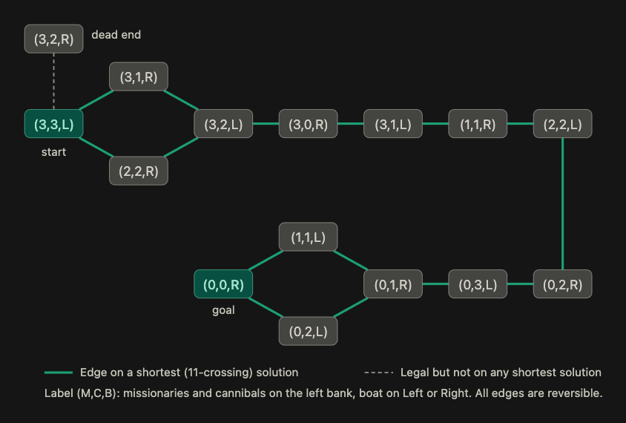

6b) The graph has cycles since every move can be undone. Without a cycle recheck, a search can repetitively retrace steps. Therefore, absolutely we should check for repeated states.
6c) People might have a hard time because the space is small, but a bad move can seem okay. Many safe moves lead to a dead end, which can only loop back to the start. Risky moves are the most rewarding. Thinking greedy fails here, so only thinking with a logical algorithm can solve the puzzle.

